**User Manual**

**Student Lifecycle Management System**

**Module-Examination**

**February 2021, Version-1.0**

**Sustainable Outreach and Universal Leadership Limited**

**Sign off Date Signature Client Signature Consulting**

Table of Contents

About this Manual 3

Module: Examination 4

1. Examination Master: 4

1.1 Exam Type 5

1.2 Assessment Criteria 6

1.3 Grading Scale 6

1.4 Student Exam Block Criteria 7

2. Examination: 8

2.1 Exam Declaration 8

2.2 Exam Application 9

2.3 Exam Paper Setting 11

2.4 Exam Block List 12

2.5 Admit Card 12

3. Assessment 14

3.1 Exam Evaluation Plan 14

3.2 Criteria-wise Evaluation 16

3.3 Continuous Evaluation 17

3.4 Final Exam Result 19

3.5 Rank List 21

4. Tools 21

4.1 Criteria Wise Evaluation Tool 21

4.2 Final Result Declaration Tool 22

4.3 Result Calculation Tool 23

# About this Manual

This User Manual acts as a reference for ERP- EduLead by describing its various concepts and abilities, and by leading the user through the basics of EduLead software. It also provides a detailed reference for all of the EduLead SLCM (Student Lifecycle Management) functionalities.

The User Manual describes all the processes and functionalities regarding various modules and its abilities to conduct the smooth transactions and integrations within the modules.

The software EduLead is open-source, easy to use and customize, actively maintained, economical and well supported.

Throughout this manual it is assumed that the reader has a working knowledge of about Student Lifecycle Management and basic computer skills and knows how to:

* Use keyboard and mouse
* Use web browsers to access the EduLead website
* Locate, open and save data files.
* Edit, cut, paste and text.

The SLCM consists of 3 Modules mainly:

1. Admission
2. Academics
3. Examination

This User Manual consists of the Examination Module for End User reference and guidance. The manual describes how to use the Standard interface. As mentioned, it contains instructions that the users must follow during the operation and servicing of **EduLead**. Diverting from the workflow as mentioned in the user manual may result in errors and non-functioning of the software EduLead. It is advisable that the end users must abide by the instructions as mentioned in the user manual.

# Module: Examination

## Examination Master:

The Examination Masters consists of transactions which would allow to determine and set the values for the Examination Module to process easily. The transactions in Examination Master consists of:

1. Exam Type
2. Assessment Criteria
3. Grading Scale
4. Student Exam Block Criteria

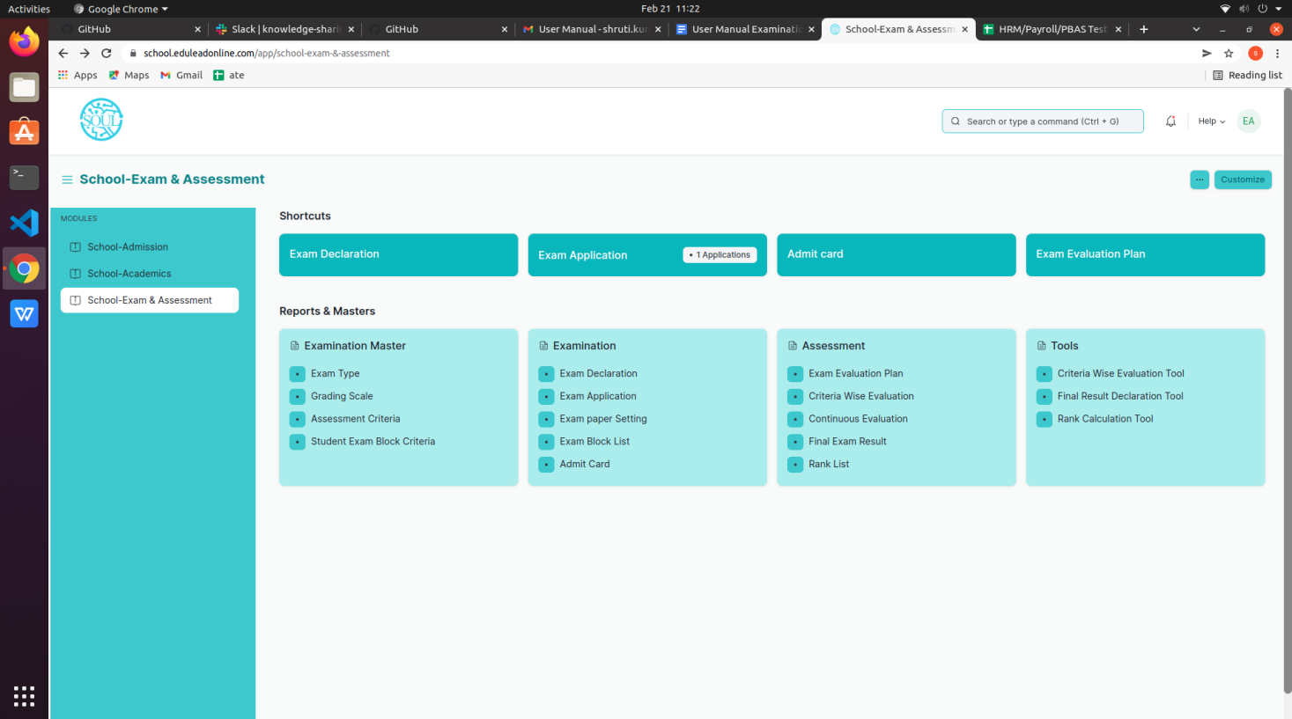

### 1.1 Exam Type

The Exam Type allows you to create and set values for a particular Exam Declaration which shall be beneficial to determine the type of examinations that are being conducted and can be evaluated on the basis of it.

For example, An Exam Declaration can be classified as a Monthly Test or Final Term Examination.

To access Exam Type list, go to:

Home >School- Examination & Assessment > Examination Master > Exam Type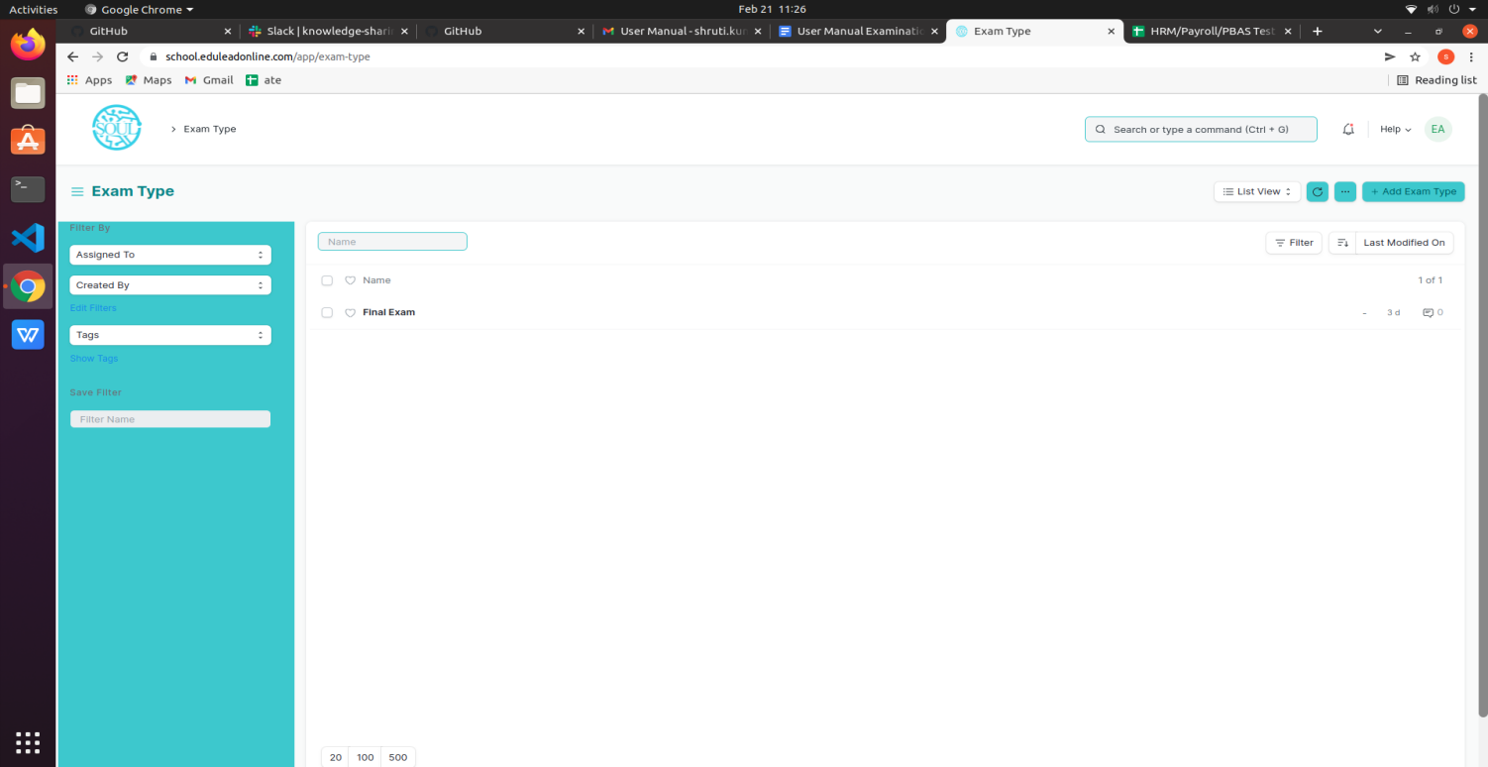

### 1.2 Assessment Criteria

The Assessment Criteria various components of Continuous Evaluation on the basis of which Evaluation shall be conducted.

Also, multiple Assessment Criteria can be grouped together under **Assessment Criteria Group** as well. It can also be linked with Exam Declaration if required.

For example, Assessment Criteria can be specified as Monthly Test, Practical, End Term, Quiz, Viva, etc.

To access Assessment Criteria list, go to:

Home >School- Examination & Assessment > Examination Master > Assessment Criteria

### 1.3 Grading Scale

Under Grading Scale, you can define the threshold for the different grades obtained by the students, based on their scores in the assessment.

For example, Students obtaining a score of 90% and above would be graded as A+, students obtaining a score of 80% and above would be graded A- and so on.

To access Assessment Criteria list, go to:

Home >School- Examination & Assessment > Examination Master > Grading Scale

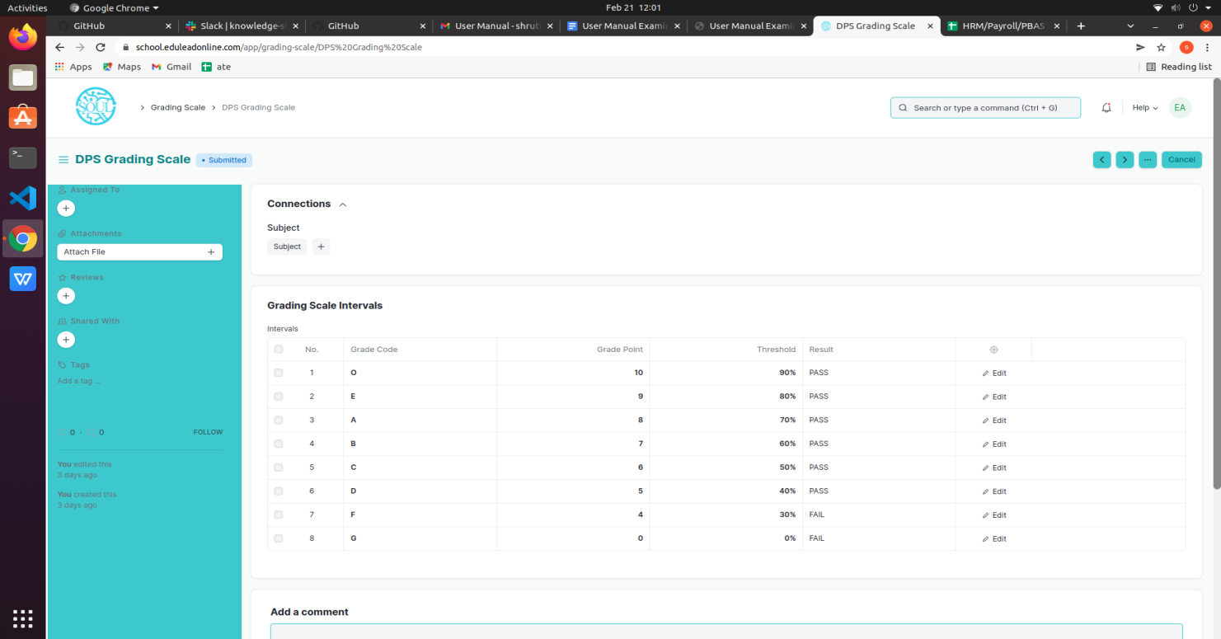

### 1.4 Student Exam Block Criteria

The Student Exam Block Criteria is used to create various criteria based on which students are blocked from applying for an exam declaration.

For example, Attendance Fees can be used as Student Exam Block Criteria for an Exam Declaration.

To access Assessment Criteria list, go to:

Home > School- Examination & Assessment > Examination Master > Student Exam Block Criteria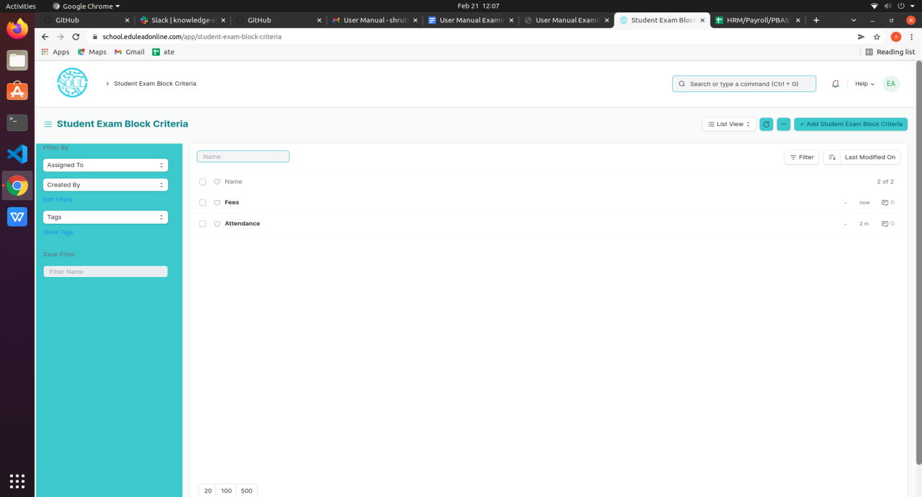

## 2. Examination:

### 2.1 Exam Declaration

The Exam Declaration will allow you to declare an exam for various class with accordance

to the ‘Academic Calendar’ template which was used during the start of each session.

To access the Exam Declaration Process, go to:

Home > School- Examination & Assessment > Examination>Exam Declaration

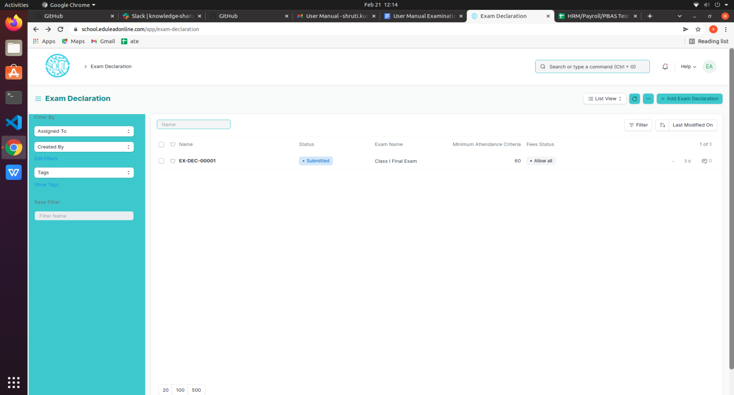

The Exam Declaration can be declared with or without the requirement of an Exam Application.

#### Prerequisites:

1.Academic Calendar

2.Class

3.Academic Year

#### How to create an Exam Declaration?

1. Add Exam Declaration: Enter the Exam Type, Exam Name, Academic Year.
2. If Exam Application is required then mark the checkbox: Enter Application Form Start Date, Application Form End Date
3. Select and add the Exam Start Date.
4. Select and add the Exam End Date.
5. Select and add the Block List Display Date.
6. Select and add the Admit Card Issue Date.
7. Select and add the Exam Level.
8. Classes related to the selected Exam Level will be displayed on the drop-down list.
9. Select Get Subjects.
10. Subject Offered Table:
    1. Subjects from the classes selected are auto populated in the table.
    2. Select and the Examination Date
    3. Change the “From Time” and “To Time” to your desirable schedule.
    4. Total duration (in Hours) will be auto generated.
11. Select and enter the eligibility details:
    1. Select and add Minimum Attendance Criteria
    2. Select the Fee Status from the list of drop-down options
12. Select and add Exam Fees:
    * 1. Select and add Exam Fees if applicable-If Yes, then select and add various fee structures along with due date in the fee structure table according to Student Category.

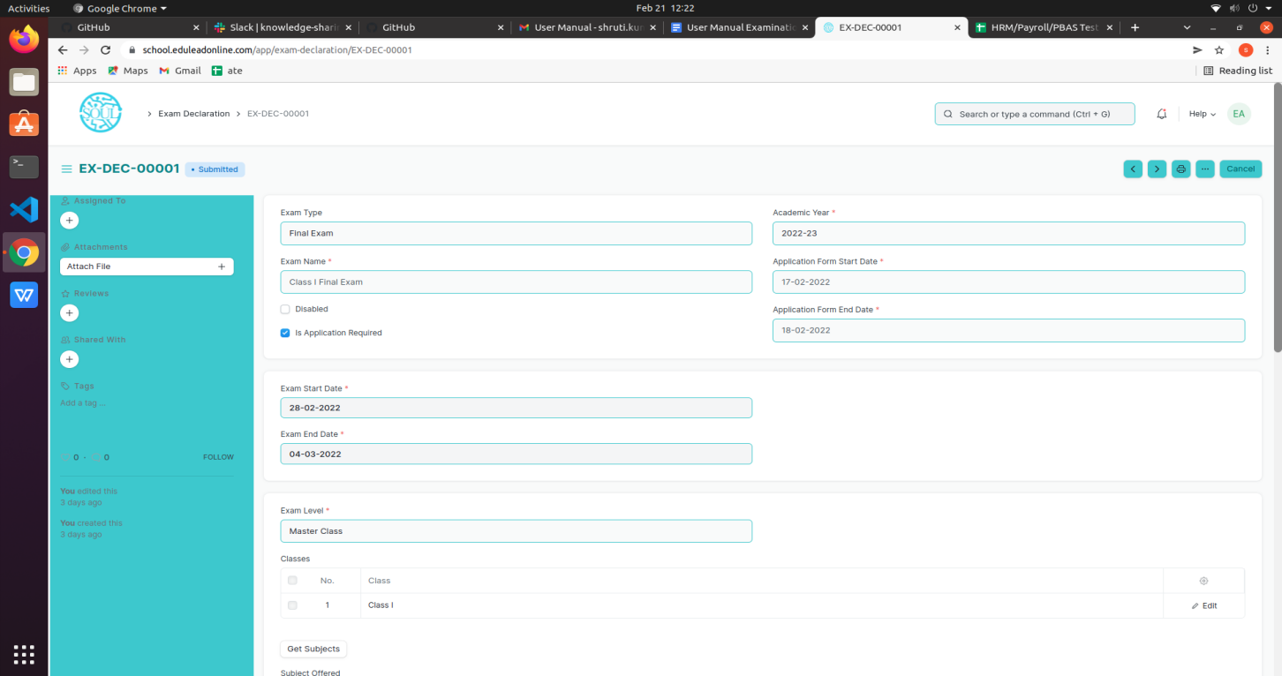

### 2.2 Exam Application

The Exam Application will allow you to apply for an exam that has been declared for a particular class according to the ‘Academic Calendar’ template which was used during the start of each session.

To access the Exam Application Process, go to:

Home > School- Examination & Assessment > Examination>Exam Application

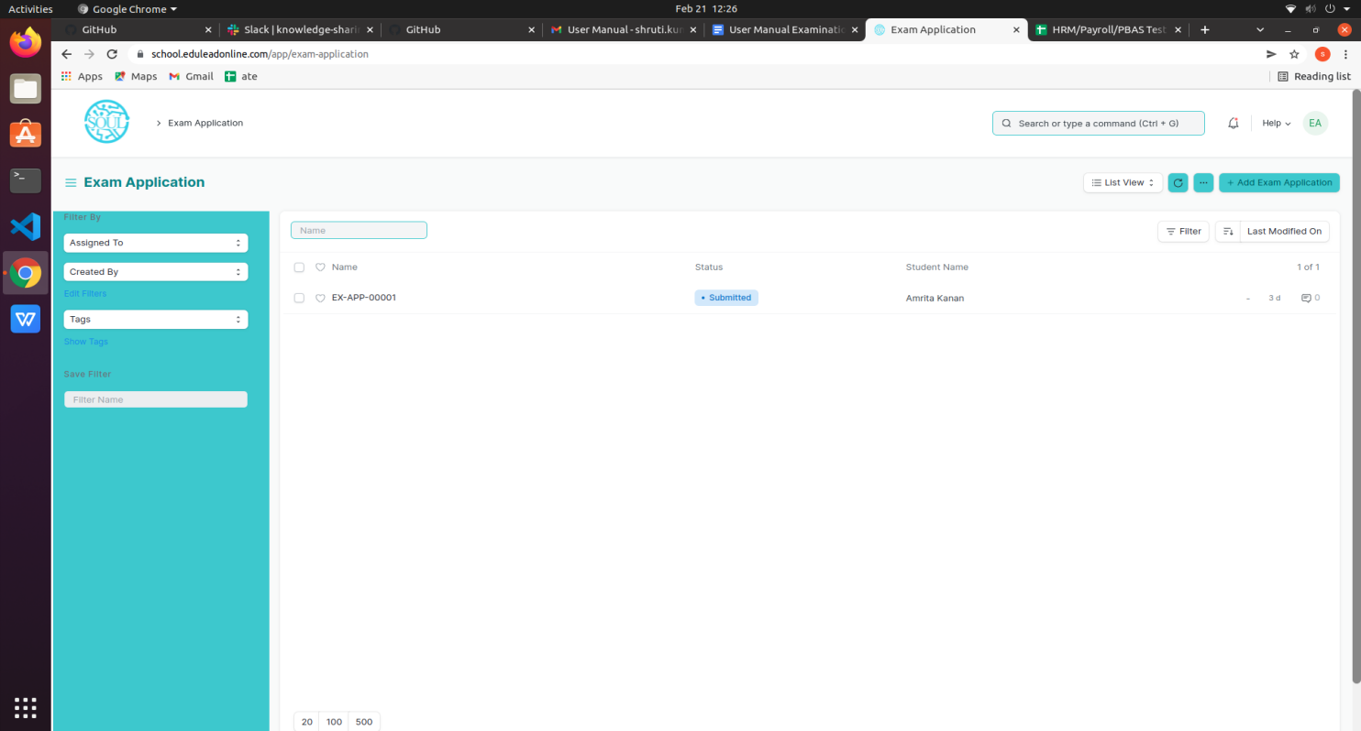

#### Prerequisites:

1.Exam Declaration

#### How to create an Exam Application?

1. Add Exam Application: The current date is auto fixed and cannot be changed.
2. Select and Add Student
3. Student Name automatically is reflected in the below field.
4. Select and Add the Exam Declaration for which the student is applying.
5. Data is auto fetched for:
   1. Class Academic Year
   2. Exam Fees
6. Select the Save button
7. Current Academic Subjects will be automatically fetched.

### 2.3 Exam Paper Setting

The Exam Paper Setting is used to prepare paper setting schedules and plan for paper setters and moderators for a particular exam declaration.

To access the Exam Paper Setting, go to:

Home > School- Examination & Assessment > Examination > Exam Paper Setting

#### Prerequisites:

1.Exam Evaluation Plan

2.Exam Declaration

**Note: The Exam Paper Setting is already created as a draft when the Exam Evaluation Plan is submitted. The Paper Setter has to only attach the exam paper set for that particular exam declaration and then approved by the Moderator if any. **

#### How to create an Exam Paper Setting?

* + - 1. Select and Add Exam Paper Setting:
      2. Select and Add Exam Evaluation Plan, Academic year.
      3. Select and add Subject.
      4. Select the Examiner from the dropdown menu and then the Moderator Name.
      5. Select the Schedule Date: Select “From Time” & “To time”.
      6. Select and attach the Paper Copy.
      7. Save.

### 2.4 Exam Block List

The Exam Block List displays the list of students that are blocked from applying for a particular Exam Declaration as they are not able to clear the eligibility exam criteria.

To access the Student Exam Block List Process, go to:

Home > School- Examination & Assessment > Examination> Exam Block List

#### How to create a Student Exam Block List?

1. Add Student Exam Block List: Select and add Level of Exam.
2. Select and add Exam Declaration
3. Class is auto fetched
4. Select and add row in Student Block Item:
   1. Enter Student ID
   2. Student Name is auto fetched
   3. Select and add criteria
5. Select Save button

### 2.5 Admit Card

The Admit Card process is used to download the admit card after an exam application has been applied for the particular exam declaration.

To access the Admit Card Process, go to:

Home > School- Examination & Assessment > Examination> Admit Card

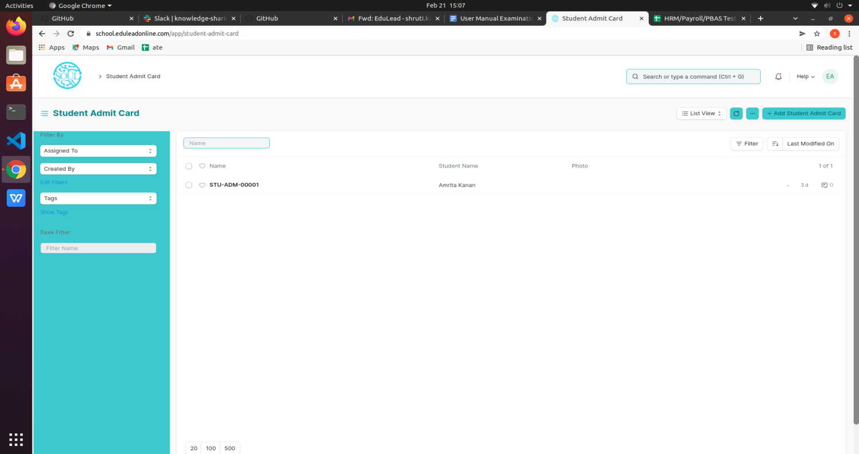

#### Prerequisites

* + - 1. Exam Declaration
      2. Exam Application
      3. Eligibility Criteria
      4. Admit Card Issue Date

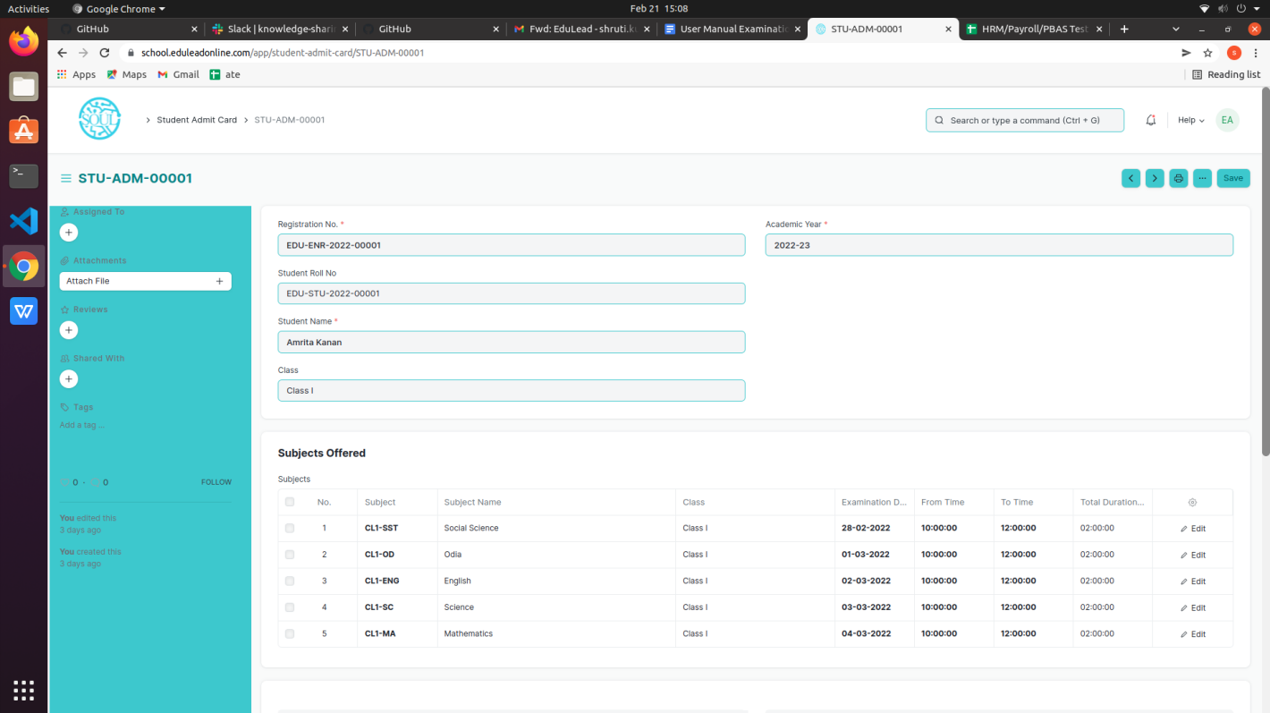

### How to create an Admit Card?

1. Select Add Student Admit Card
2. Select and Add Registration No
3. All other fields are auto fetched accordingly
4. Add Save button

### Other Features

1. The Admit card can be viewed in print form and downloaded.
2. The admit card contains information regarding the exam schedule.
3. It also contains a photo of the student.

### 

## 3. Assessment

## 3.1 Exam Evaluation Plan

An Exam Evaluation Plan is a schedule to conduct the examination/assessment of a particular subject for a group of students studying that subject in an on-going academic year.

To access the Exam Evaluation Plan, go to

Home > School- Examination & Assessment > Assessment> Exam Evaluation

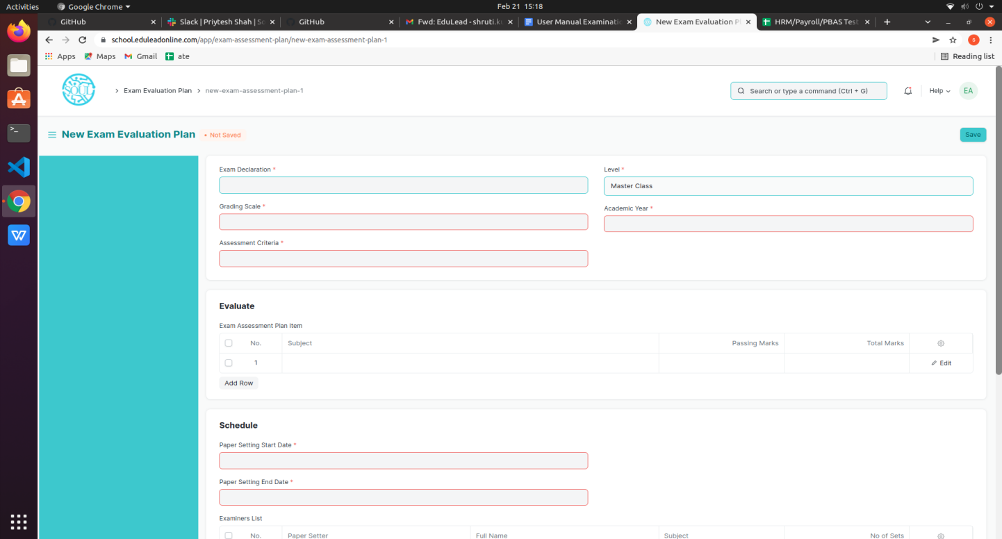

#### Prerequisites

Before creating an Exam Evaluation Plan, it is advisable that you create the following first:

1. Student Group (Based on Exam Declaration)
2. Subject
3. Class
4. Evaluation Group
5. Grading Scale

#### How to create an Exam Evaluation Plan?

1. Go to the Exam Evaluation Plan list and click on New.
2. Select the Exam Declaration for which you want to conduct the evaluation plan.
3. Select the Academic Year,Grading Scale, Assessment Criteria for which you are conducting the evaluation plan.
4. The subject for which the exam declaration has been made, gets auto fetched in the “Evaluate” table along with passing marks and total marks.
5. Select the Paper Setting Start Date and Paper Setting End Date.
6. Select the faculties in the Examiners List and select the subject which are present in their respective Teacher log.
7. Select the faculties as Moderators along with the subject specific to them.
8. Save.
9. Once you save the Exam Evaluation Plan, the Exam Paper Setting would automatically be created for the evaluation which needs to be verified and submitted.
10. Submitted.

#### Features

#### Exam Schedule

1. Schedule Date: Enter the date on which the evaluation is to be conducted.
2. From Time: Enter the start date for the evaluation.
3. To Time: Enter the end time for the evaluation.
4. Room: Select the room in which the evaluation would be conducted.
5. Examiner: Add the name of the Examining Teacher for this assessment.
6. Supervisor: Add the name of the Supervising Teacher for this assessment.

### 3.2 Criteria-wise Evaluation

Criteria-wise Evaluation allows us to create an evaluation for a particular assessment criterion in a subject for a student enrolled in that subject.

To access the Criteria-wise Evaluation, go to:

Home > School- Examination & Assessment > Assessment > Criteria wise Evaluation

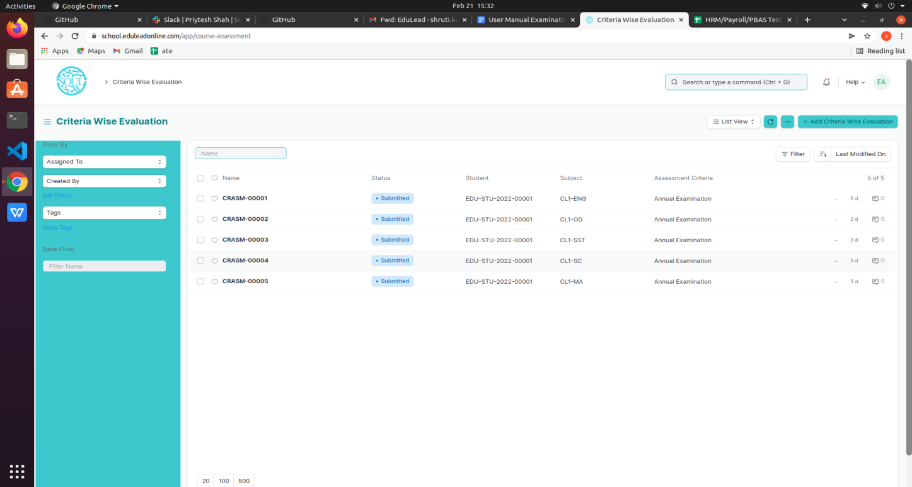

#### Prerequisites

Before creating Criteria-wise Evaluation, it is advisable that you create the following first:

1. Exam Declaration

2. Subject

3. Assessment Criteria

4. Exam Evaluation Plan

5. Grading Scale

#### How to create Criteria-wise Evaluation?

1. Go to Criteria Wise Evaluation; Select and add Criteria Wise Evaluation.
2. Select and enter the Student Name
3. Select and enter Academic Year.
4. Select the Subject from the dropdown list.
5. Select and add Assessment Criteria.
6. Select and add Exam Declaration and Exam Evaluation Plan if any.
7. Save.

### 3.3 Continuous Evaluation

Continuous Evaluation is used to assess the Assessment Criteria done for a subject for an individual student.

To go to Continuous Evaluation, go to:

Home >School- Examination & Assessment > Assessment > Continuous Evaluation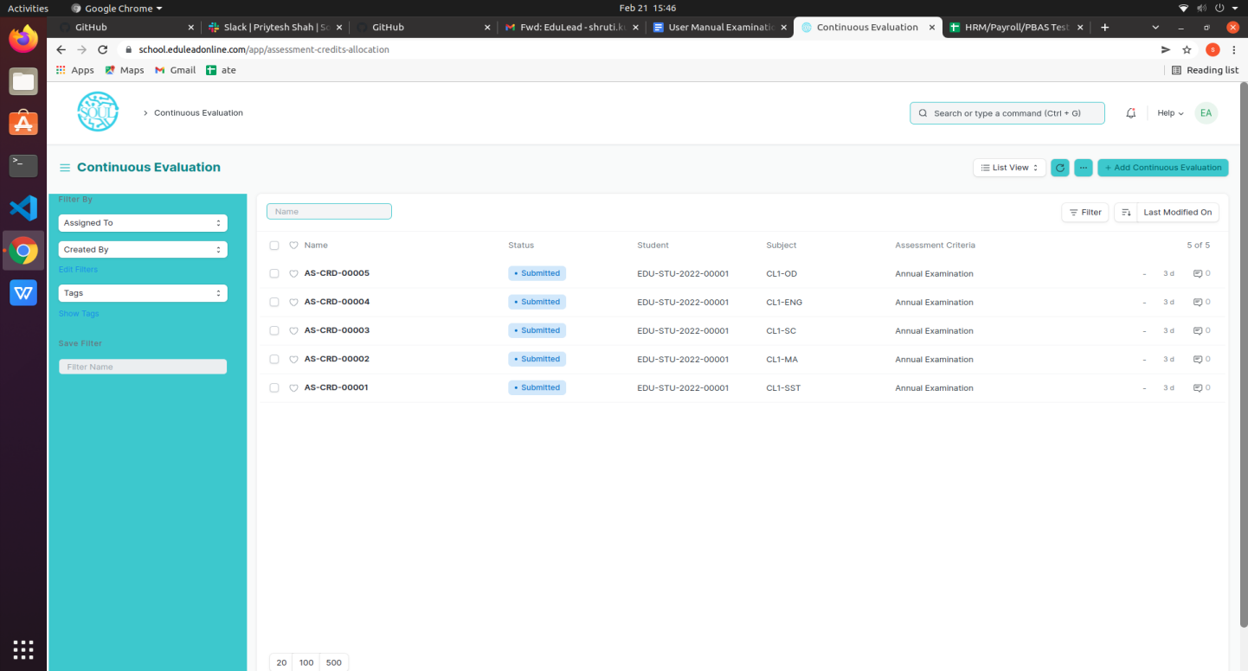

#### Prerequisites

Before creating Continuous Evaluation, it is advisable that you create the following first:

* + - 1. Criteria wise Evaluation

#### How to create Continuous Evaluation?

1. Go to Continuous Evaluation; Select and add Continuous Evaluation.

2.Select and enter the Student Name

3. Select the Subject from the dropdown list.

4. Select and add Assessment Criteria.

5. Select Get Assessments.

6. The Assessment Criteria for that particular subject is auto fetched.

7. Enter Grace Marks if required.

8. Weightage Marks are auto fetched.

9. Enter the Final Marks after any revision.

10.Save.

### 

### 

### 

### 

### 

### 

### 3.4 Final Exam Result

Final Exam Result is used to evaluate the final assessment of a student for a particular class.

To go to Final Exam Result, go to:

Home >School- Examination & Assessment > Assessment > Final Exam Result

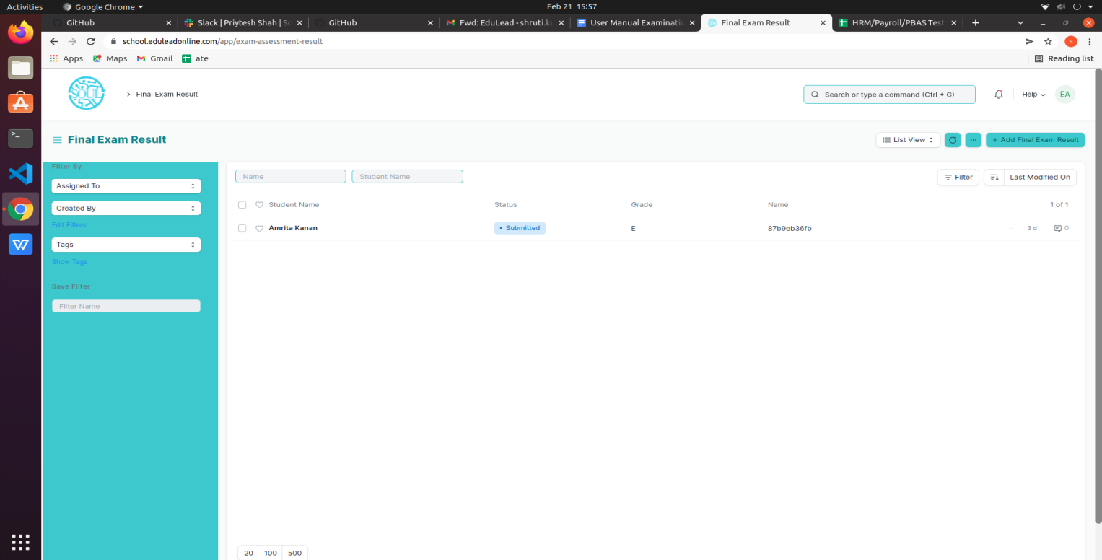

#### Prerequisites

Before creating Final Exam Result, it is advisable to create the following first:

* + - 1. Criteria wise Evaluation
      2. Continuous Evaluation

#### How to create a Final Exam Result?

1. Go to Final Exam Result; Select and add Final Exam Result.
2. Select and enter the Student Name
3. All the information required is auto fetched.
4. Select and add Grading Scale.
5. Select Get Result.
6. The Assessment Result items for that particular student are auto fetched.
7. The Evaluation Result item is also auto fetched and calculated on the basis of grading scale.
8. The SGPA, Percentage and Grade are also calculated and automatically fetched.
9. Submit and Save the Final Exam Result.
10. The final exam result is declared for a particular Student.

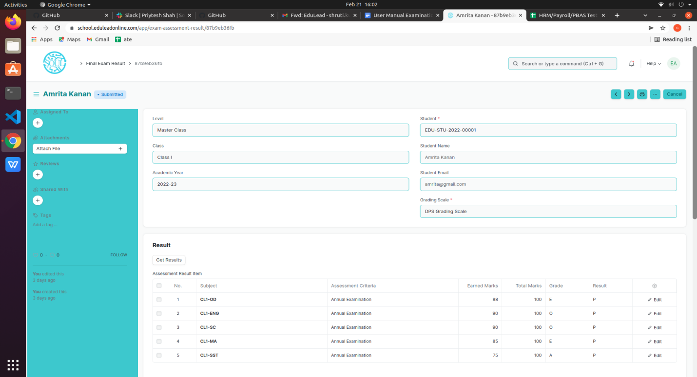

### 

### 3.5 Rank List

Rank List provides the Rank List of different Classes after the declaration of the Final Exam Result.

To go to Rank List, go to:

Home >School- Examination & Assessment > Assessment > Rank List

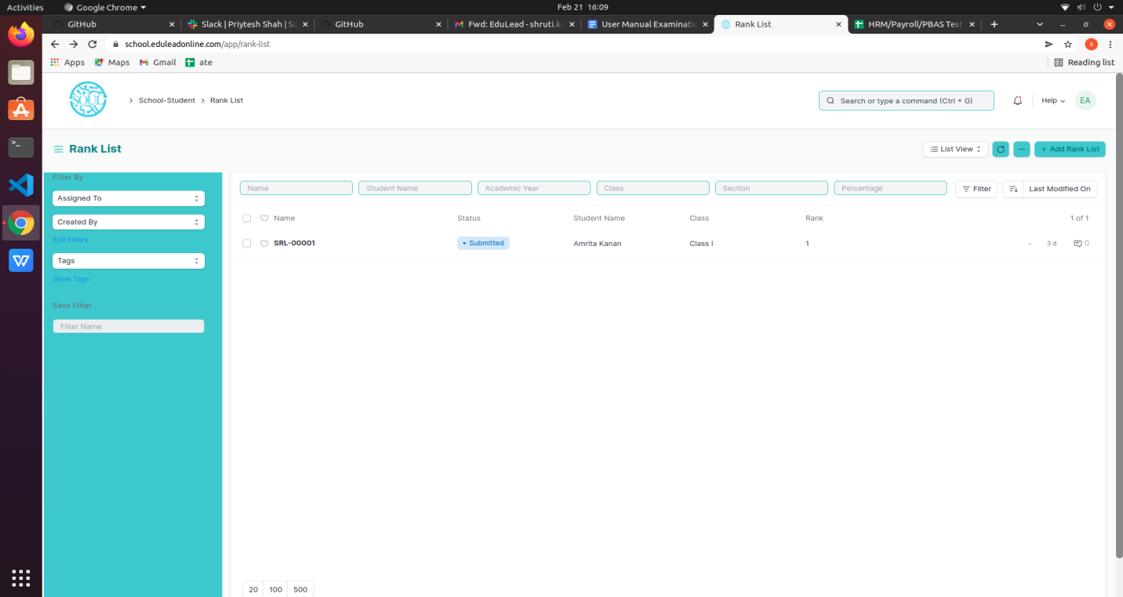

#### How to Create Rank List?

Rank List will be Generated by using Rank Calculation Tool and cannot be created from here but the records are read only.

## 4. Tools

### 4.1 Criteria Wise Evaluation Tool

Criteria Wise Evaluation Tool helps in entering marks earned by the students in a class for a particular subject and particular assessment criteria.

To go to Criteria Wise Evaluation Tool, go to:

Home >School- Examination & Assessment > Tools > Criteria Wise Evaluation Tool

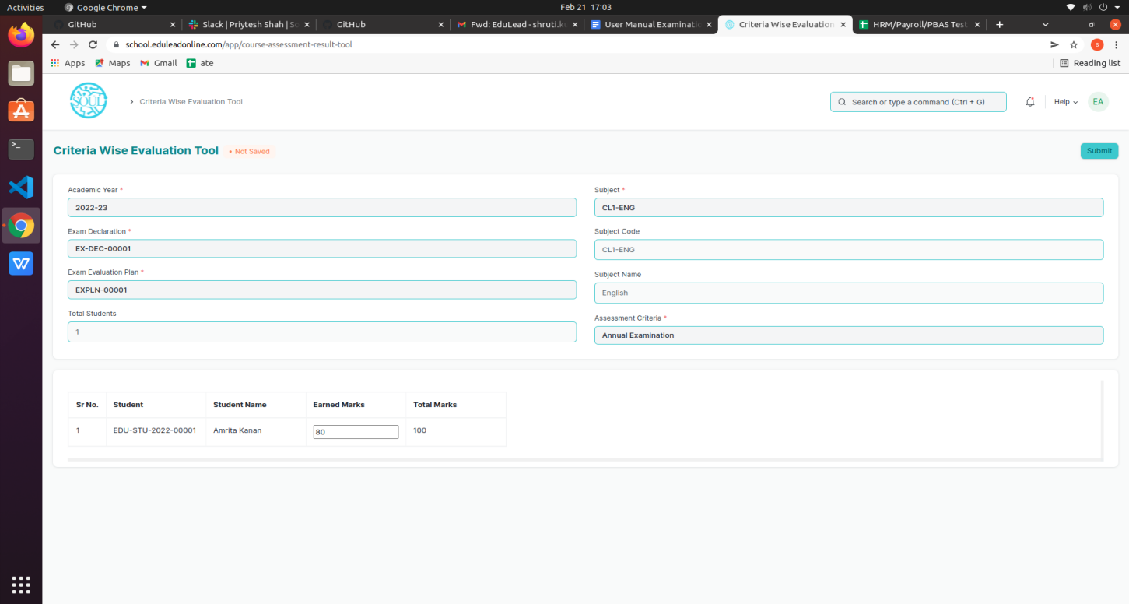

#### How to use a Criteria Wise Evaluation Tool?

1. Go to Criteria Wise Evaluation Tool.
2. Select and add Academic Year.
3. Select and add Class.
4. Select and add a Subject for which assessment criteria is to be evaluated.
5. Select and add Assessment Criteria.
6. If the Assessment Criteria is linked to any exams, then:
   1. Select and add Exam Declaration from the dropdown list.
   2. Select and add Exam Evaluation Plan from the dropdown list.
7. The total number of Students along with the Student list is fetched.
8. Select and enter the marks for each student in the Earned Marks field.
9. Save.

The entries for all the Students’ Criteria Wise Evaluation is created in the Criteria Wise Evaluation Document which can be verified and finally submitted.

### 4.2 Final Result Declaration Tool

Final Result Declaration Tool is used to declare the final exam results for a particular group/batch of students in a class.

To go to Final Result Declaration Tool, go to:

Home >School- Examination & Assessment > Tools > Final Result Declaration Tool

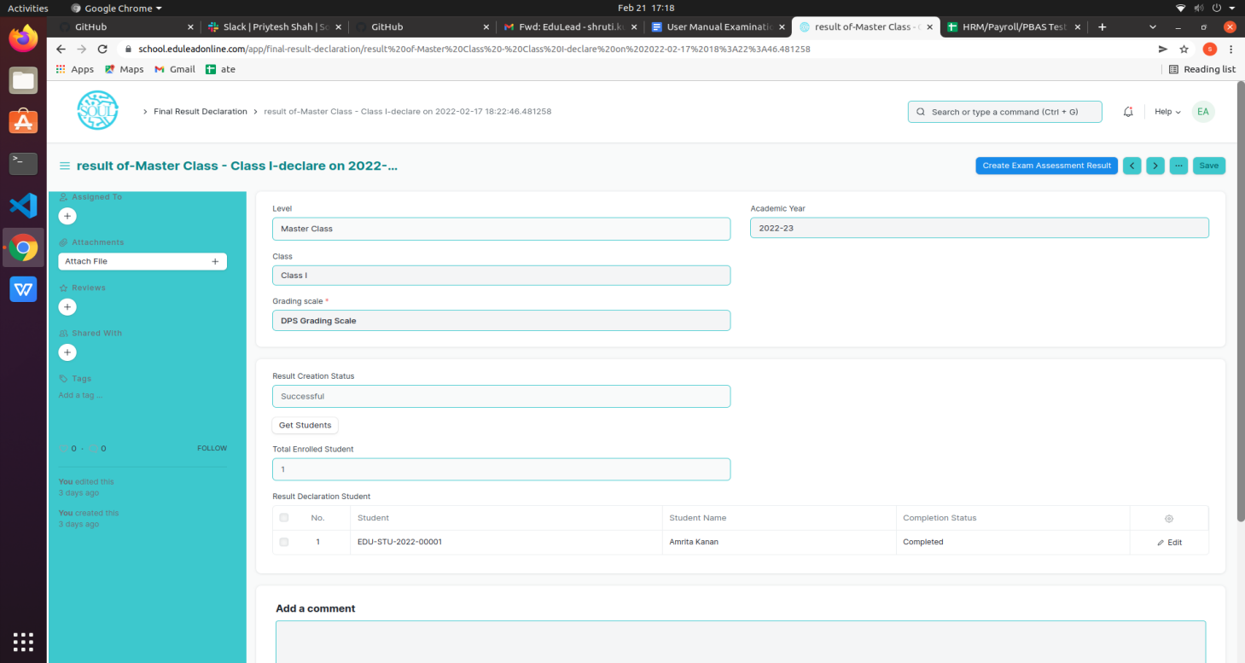

#### How to use the Final Result Declaration Tool?

Go to the Final Result Declaration Tool; Add Final Result Declaration.

Select and add Class.

Select and add Grading Scale.

Select and add Academic Year.

Select “Get Students”.

Total Enrolled Students is shown in the field.

The Result Declaration Student List is auto fetched along with Completion Status/Pending Status.

Save.

The draft entries from the Final Result Declaration Tool are created in Final Exam Result.

The draft entries are now then verified and submitted.

### 4.3 Rank Calculation Tool

Rank Calculation Tool is used to calculate the Rank for a particular group/batch of students in a class.

To go to Final Result Declaration Tool, go to:

Home >School- Examination & Assessment > Tools > Rank Calculation Tool

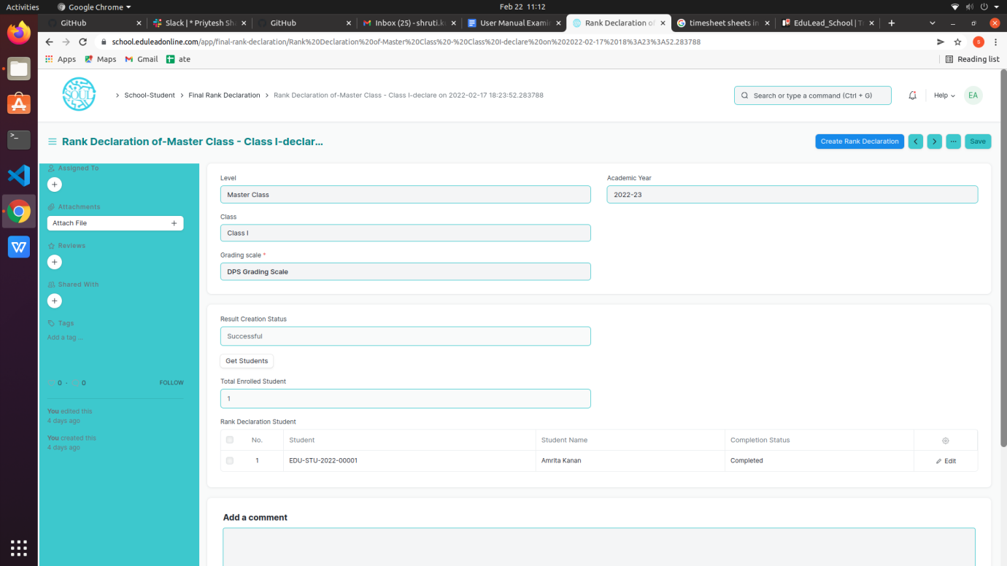

#### How to use the Rank Calculation Tool?

1. Go to the Rank Calculation Tool; Create Rank Declaration.
2. Select and add Class.Final Result Declaration Tool
3. Select and add Grading Scale.
4. Select and add Academic Year.
5. Select “Get Students”.
6. Total Enrolled Students is shown in the field.
7. The Rank Declaration Student List is auto fetched along with Completion Status/Pending Status.
8. Save.
9. The entries from the Rank Calculation Tool are created in Rank List